Lab 1: Experimental Design, Lab Fundamentals and Diffusion

Learning Goals:

- Briefly describe the scientific method
- Create a hypothesis and use it to make a prediction
- Design an experiment with appropriate controls
- Describe independent/dependent variables, control groups, and replication
- Prepare graphs and learn how to use the best fit line equation to solve for unknown data points
- Learn the correct use of a micropipette
- Use the metric system to convert between units of volume
- Describe the process of diffusion

Introduction

Our first lab will cover key concepts related to experimental design. We’ll also review several lab fundamentals, including metric conversions, how to properly use a micropipette, and how to prepare and analyze graphs. Additionally, we'll explore the concept of diffusion.

Part 1: Experimental Design

Science is both a body of knowledge AND a process (method) for learning more about our world. The scientific method is often presented as a linear series of steps in a vacuum (Fig. 1), though in reality it is a dynamic, iterative process that can be influenced at any stage. Ultimately, the process builds upon existing ideas, challenges them, and/or elucidates new ones.

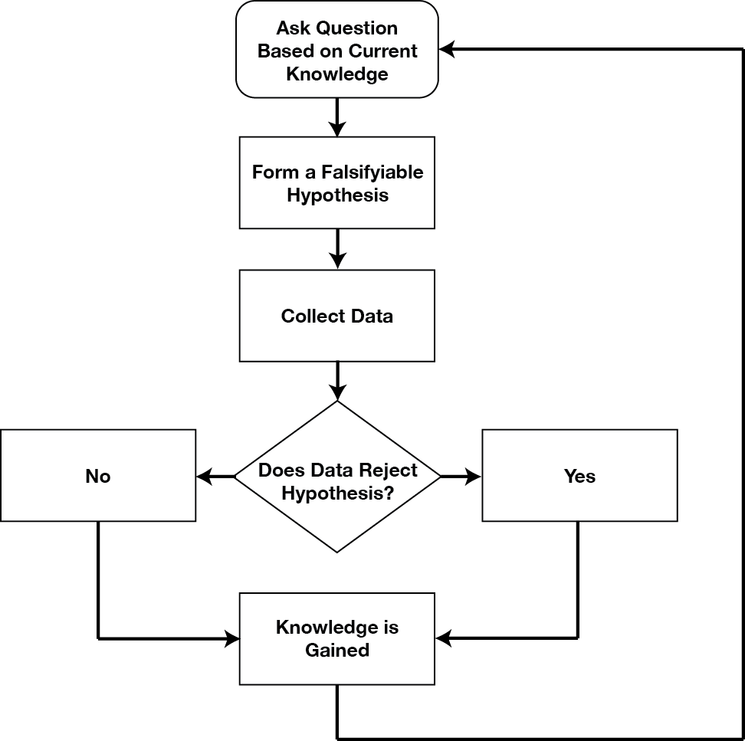
Figure 1. The Scientific Method. https://commons.wikimedia.org/wiki/File:Scientific_Method.png

The scientific process (usually) begins with an observation of a phenomenon or event; based on this observation, one can then formulate a hypothesis (a potential explanation for the event). A hypothesis must be testable and falsifiable in order to be valid; therefore, testing ideas (in the form of hypotheses) is a critical part of the scientific process. Experiments are procedures set up to test the validity of a hypothesis/our ideas under specific controlled conditions, and are the most powerful tool we have for establishing cause-and-effect relationships.
In order to conduct an experiment, a researcher must have a specific hypothesis to be tested. Hypotheses can be formulated either through direct observation of the real world or after careful review of previous research. For example, if you think that the use of technology in the classroom has negative impacts on learning, then you have basically formulated a hypothesis—namely, that the use of technology in the classroom should be limited because it decreases learning. How might you have arrived at this particular hypothesis? You may have noticed that your classmates who take notes on their laptops perform at lower levels on class exams than those who take notes by hand, or those who receive a lesson via a computer program versus via an in-person teacher have different levels of performance when tested.
These sorts of personal observations are what often lead us to formulate a specific hypothesis, but we cannot use limited personal observations and anecdotal evidence to rigorously test our hypothesis. Instead, to find out if real-world data supports our hypothesis, we have to conduct an experiment.

Experimental and Control Groups

The most basic experimental design involves two groups: the experimental group and the control group. The two groups are designed to be the same except for one difference— experimental manipulation. The experimental group gets the experimental manipulation—that is, the treatment or variable being tested (in this case, the use of technology)—and the control group does not. Since experimental manipulation is the only difference between the experimental and control groups, we can be sure that any differences between the two are due to experimental manipulation rather than chance (again, we are trying to establish a cause-and-effect relationship).
In our example of how the use of technology should be limited in the classroom, we have the experimental group learn algebra using a computer program and then test their learning. We measure the learning in our control group after they are taught algebra by a teacher in a traditional classroom. It is important for the control group to be treated similarly to the experimental group, with the exception that the control group does not receive the experimental manipulation. Next, we need to establish how we will run our experiment. In this case, we might have participants spend 45 minutes learning algebra (either through a computer program or with an in-person math teacher) and then give them a test on the material covered during the 45 minutes.

Variables

Designing a good scientific experiment involves identifying the variables that are important in the process you are investigating. A variable is any factor that may differ or change in your experiment. There is an important group of variables that you will want to remain constant throughout your experiment, and these are called controlled variables (or "constants"). For example, let’s say that you and your lab team are interested in the question, “What percentage of nitrogen in the soil will cause the garden tomatoes to grow the tallest?” Constants, or controlled variables, in this experiment would include such factors as the particular variety of tomato plant used, the amount of light each plant receives, and the form in which the nitrogen is delivered to the soil.
Your lab team would also need to identify two other important variables: the independent (manipulated) variable and the dependent variable. An independent variable is a factor that is purposefully changed by the experimenter. In the example being used, the independent variable is the percentage of nitrogen. There might be several levels of the independent variable, for example, nitrogen concentrations of 1%, 3%, 5%, 7%, and 10%. A dependent variable is the variable that responds to the change in the independent variable - as such, this is usually the variable that the scientist measures. In this experiment, the height of the plant would be the dependent variable.
This experiment would also need to have a control, a group of plants that receive no additional nitrogen. In other words, a control group is one in which the independent variable is not changed. Control groups are a way to detect or measure the influence of unanticipated factors, and they establish a base line for comparing the experimental effects of no treatment.
It is important to bear in mind that a good scientific experiment usually tests one independent variable at a time, and that is why it is important to keep all other potential variables constant and to use a control group. Also, in identifying independent and dependent variables, be sure that you specify ones that are measurable. For instance, in our example, the dependent variable was specified as the height of the plant. If instead your group were to use a vague or fuzzy dependent variable like, “plant growth,” “the health of the tomato plant,” or the “general wellbeing of the plant,” it is unclear as to exactly what you would measure.

Sources of Error

When designing and conducting experiments, it’s important to be aware of the various types and sources of error. Errors are differences between observed values and what is true in reality. Errors may cause results that are inaccurate or misleading, and may invalidate one’s data if they are significant enough. It’s important to note that experimental errors are different from “mistakes” (human/personal errors); these problems can usually be eliminated by repeating the experiment or procedure correctly.
Experimental errors, however, are inherent in the measurements themselves and can’t be removed by simply repeating the experiment (no matter how carefully). The two main types of experimental errors are:

Random errors: Errors that occur due to chance, and have no pattern. There is always some variability when a measurement is made (from slight fluctuations in an instrument, the environment, the way a measurement is read, etc.). To address random error, we will utilize replication (repeating a measurement many times) in our experiments.

Systematic errors: Consistent, repeatable errors that affect the accuracy of a measurement. These types of errors are sometimes described as “same direction” or “one-sided” errors since they usually differ by the same amount from the “true” (accepted) value (in the absence of other types of errors), e.g., you consistently add 1mm to a series of length measurements due to misreading the increments on a metric ruler. Systematic errors are difficult to detect (they’re not easily analyzed by statistical analyses), and can only be reduced by refining the measurement method or technique.

Introduction to C.U.R.E. project and lab report

Tetrahymena are single-celled, eukaryotic organisms widely used in biological research. There are many advantages to using this freshwater protozoan for research: it’s inexpensive, easy to culture/maintain, and has a short generation time. Despite being unicellular, Tetrahymena’s complexity rivals our highly specialized human cells, and it shares many genes and processes with multicellular organisms that are typically absent in other unicellular organisms. Due to these features, it continues to be a useful model organism to investigate a plethora of genetic, cellular, and molecular processes (Fig. 2).

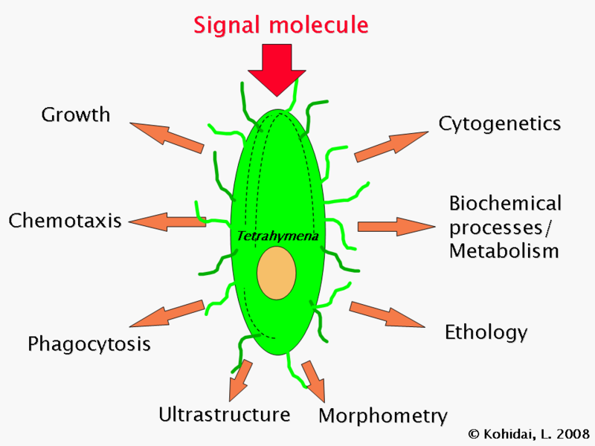
Figure 2. Tetrahymena research. https://commons.wikimedia.org/wiki/File:Tetrahymena-research.png

This semester, you will be performing a series of experiments using the organism Tetrahymena thermophila in order to learn more about its physiology and response to environmental factors. More specifically, you will be conducting experiments on Tetrahymena as a proxy to learn more about anthropogenic effects (human impacts) on natural environments where the organism is primarily found (streams, lakes and ponds). Alternatively, you can decide to investigate the effects of a substance on eukaryotic cells (using Tetrahymena as your model organism). To do this, your group will be manipulating unique independent variables in each of the following lab activities:
- Chemotaxis: movement of Tetrahymena in response to a substance in its environment
- Bioconvection: effects of an independent variable on pattern formation in Tetrahymena
- Osmosis: effects of a substance on contractile vacuole activity in Tetrahymena
- Phagocytosis: effects of a substance on phagocytosis/food vacuole formation in Tetrahymena
It’s important to note that for the most part, you will not be designing entirely unique or different lab activities from those contained in this manual (we are limited by the duration of each 3-hour lab period as well as our department’s lab equipment, supplies and technical services). Instead, each group will be performing the same 4 general activities, but will test different independent variables. The standard protocols should not need to be changed. Our goal is to have you gain experience in developing testable hypotheses, devising methods to test your hypotheses (based on our lab activities in Weeks 5 and 6), performing experiments, collecting useful data, and analyzing/interpreting experimental results. Your methods, data, and results/conclusions will be communicated through your C.U.R.E (Course-based Undergraduate Research Experience) lab report at the end of the semester. Ideally, the variables/conditions that you explore in each of the four C.U.R.E. lab activities (and the data you collect in each experiment) can be connected in some relevant way in your report.
A little knowledge of Tetrahymena physiology, ecology, and behavior will go a long way in the development of good, testable hypotheses; so, you’ll need to do some independent research/literature searches on Tetrahymena to inform your hypotheses (information on how to conduct a peer-reviewed literature search will be provided). You will then need to submit an Annotated Bibliography along with a “Research Plan” during Week 3 of lab. This Research Plan will ensure that your group has prepared testable hypotheses and a feasible plan before beginning your experiments in Weeks 5 and 6; you will receive feedback on your plan from your instructor in Week 4. A thoughtful research plan will explain the relevance/importance of your experiments (e.g., measuring the potential environmental effects of an everyday household item whose toxicity is assumed to be minimal) and anticipate needs as much as possible. It’s not enough to write, “We’re going to add a bunch of acid and see what happens”. Instead, you need to decide what acid (and why), at what concentration, explicitly define dependent/independent variables, etc. Also, give serious thought to HOW you will use your results to evaluate your hypotheses, whatever they may be. To provide some scaffolding for your group’s plans, the next section summarizes each activity’s procedure and the type of observations/data that will be collected. For more details on a specific activity, please look through Labs 5 and 6 in this manual. Research plan guidelines will be provided in a separate document.
By participating in scientific inquiry, you will be doing something very similar to what professional scientists do every day. This can be fun and interesting, but can also be challenging. So, keep an open mind and don’t get discouraged! You shouldn’t feel as though you have somehow failed if your hypotheses are not supported by your data (after all, a hypothesis that cannot be rejected is not a good hypothesis). Finding that a variable has “no effect” is a result, not a failure.

Lab 1 Part 1: Lab Fundamentals

A) Micropipettes (and how to use them)

The micropipette (also referred to as a pipettor or micropipettor) is a common laboratory instrument used for transferring microvolumes of liquid solutions. Micropipettes come in a range of sizes for the accurate movement of volumes between 0.5 and 5000 μl. Each instrument requires one of three different sized disposable tips, though we will only use two different size tips in this course. Micropipettes work by displacing air from the pipette shaft, allowing the liquid to be drawn into the resulting vacuum. Their uses include transferring cell suspensions for a variety of cell-based assays, loading samples for different analytical techniques, and mechanically disrupting tissues into single cell suspensions. Micropipettes are an extremely helpful laboratory tool that are easy to use with a little bit of instruction and practice. Before setting up your diffusion experiment (Part 3), watch the “How to Micropipette” video (shown by your instructor/on Canvas), read the information below and practice using the micropipettes by moving small volumes of water to the specified container. Proper use of the pipettes is an essential skill for many activities in Biol 1A lab, but also for your future courses and in many laboratory occupations.

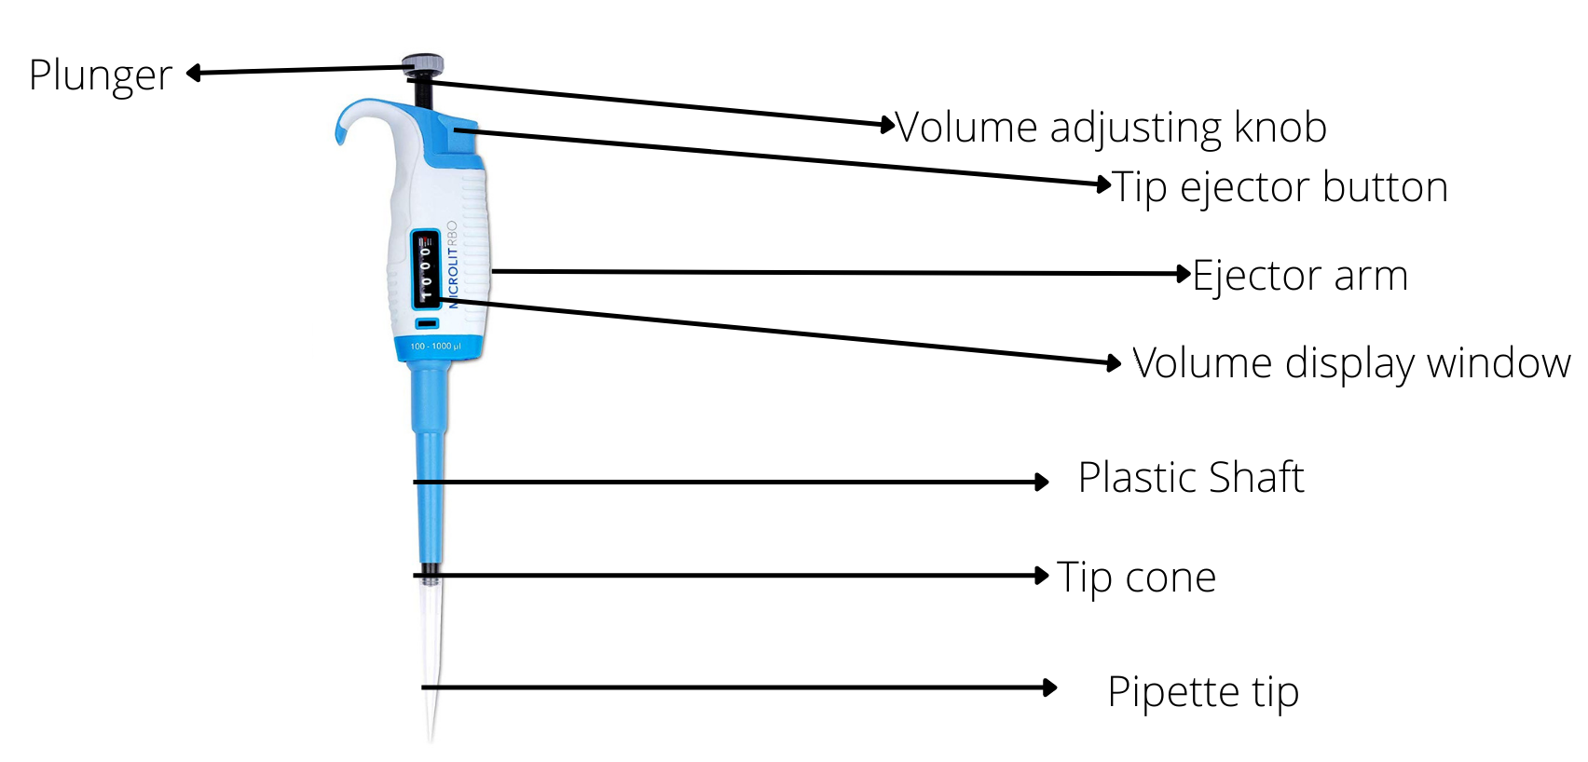
Figure 5. Micropipette diagram.

Metric Conversions
It is important to become familiar with metric units of measurement and their conversions. Scientists exclusively use the metric system for measurements. If you are unfamiliar with the metric system We will concentrate on liquid measurement (based on the liter), but the prefixes also apply to dry measurements (based on the gram). The two most prevalent units of liquid measurement in biology are the milliliter (ml) and microliter (µl).

1ml = 1/1,000 (1.0x10⁻³) liter 1,000 (1.0x10³) ml = 1 liter
1µl = 1/1,000,000 (1.0x10⁻⁶) liter 1,000,0000 (1.0x10⁶) µl = 1 liter
1µl = 1/1,000 (1.0x10⁻³) ml 1,000 (1.0x10³) µl = 1ml

Our lab uses a variety of pipettor brands; each has a particular way of displaying the set volume (in microliters) on its volume display window. You will find that all Fisherbrand and Eisco pipettes have a horizontal display (digits are read left to right), whereas other brands may have a vertical display (digits are read top to bottom). Make sure you check the specific layout of your micropipette before use.

Volume display window indicates: | Actual volume:
P-1000 pipettor (vol. range of 100 to 1000 µl)  (vertical display)  (horizontal display) | 0.75ml or 750 µl
  0
  7
  5
  0
  0 | 7 | 5 | 0
P-200 pipettor (vol. range of 20 to 200 µl)  (vertical display)  (horizontal display) | 0.15ml or 150 µl
  1
  5
  0
  1 | 5 | 0
P-20 pipettor (vol. range of 2 to 20 µl)  (vertical display)  (horizontal display; rightmost digit is 1st decimal place) | 0.0125ml or 12.5 µl
  1
  2
  .5
  1 | 2 | 5

Proper Micropipette Use:
Remember these important rules when using a micropipette:
- Never attempt to use the pipet without a tip in place; this would ruin the precision piston that measures the volume of fluid.
- Never lay down a pipet that has a filled tip; fluid could run back into the piston.
- Never let the plunger snap back after withdrawing or ejecting fluid; this could damage the piston.
- Never twist the volume adjustment knob beyond its upper/lower limits; this will break/jam the micropipette spring

Here are some general steps on using a micropipette. Please watch the provided video shown by your lab instructor as a visual aid.

- Rotate the volume adjustment knob to your desired quantity. Notice the change in the plunger length as the volume is changed.
- Push tip cone (end) firmly into a proper-size tip (yellow and blue tips hold different volumes). Dispose of a tip (after use) by pushing on the ejector button over a waste container.
- While withdrawing or expelling fluid, always hold the vessel at or near eye-level. It is important that you watch while you pipette. Hold the pipet almost vertical when filling it.
- There are two ‘stops’ on the pipette plunger. Push the plunger down until you feel resistance; this is called the ‘first stop’. Practice pressing the plunger down to this stop a few times. Next, push the plunger all the way down to the ‘second stop’. You will use the second stop when dispensing volumes from your pipette.
To draw liquid into the pipette (aspirate):
- Press the plunger to the first stop, and hold in this position. Then place your attached tip into the liquid and slowly release the plunger. This wall draw the correct volume of liquid into your tip (indicated on your volume display window).
- Slide tip out along the inside wall of the reagent tube to dislodge any excess fluid adhering to the outside of tip.

To dispense liquid into a new container:
- Touch pipet tip to the inside wall or bottom of your tube, if your tube is empty. See next step for details on dispensing into other liquid volumes. As mentioned before, it’s helpful to hold your tube at eye-level so that you can see where exactly you’re dispensing the liquid.
- To expel sample, slowly depress button to the first stop. Then press down to the second stop to dispense the last bit of fluid. Hold the plunger down at the second stop. NOTE: if your tube already has liquid in it, make sure the tip of your pipette is touching that liquid before dispensing to ensure proper mixing (and prevent small droplets from sticking to the pipette tip).
- Pull your pipette away before releasing the plunger to ensure that the liquid is not drawn back into the pipette.
- To eject the tip, press the “ejector button” on the side of the pipettor. Keep a waste beaker on your lab bench into which you can directly eject used pipette tips. To prevent contamination of your reagents:
- Always add appropriate amounts of a single reagent sequentially to all reaction tubes. The same tip can be used if you are pipetting multiple aliquots of the same substance, or moving from a lower concentration to a higher concentration of the same substance.
- Release each reagent drop onto a new location on the inside wall of the reaction tube.
- Use a fresh tip for each new reagent you pipette.

Mixing solutions:
1) If you need to mix a solution by pipetting, place your tip into the liquid and carefully push the plunger to the first stop several times. Keep the tip in the liquid at all times while mixing. Avoid bubbles by pipetting up and down slowly, and don’t press the plunger past the first stop.
2) When done mixing, push the plunger down to the second stop and remove the pipette from the liquid.

Exercise 1: Micropipette practice using p1000 and p20 micropipettes

The ‘p1000’ micropipette (for volumes ranging from 100 to 1000 µL):
- Fill your group’s beaker with some deionized water from the carboys at each sink.
- Transfer the following water volumes from your group’s beaker to the provided test tube (on your group’s tray). Each group member should participate by pipetting each of the volumes below. Be sure to use the correct micropipette for each volume, as each requires a different size tip (either blue or yellow). Refer to the instructions above as needed.

With your ‘p1000’ (100-1000 uL) micropipette (use the blue tips), obtain the following volumes:
  - 100 uL (this is the lower limit of your p1000 micropipette; do not twist the volume knob past this point)
  - 500 uL
  - 1000 uL (this is the upper limit of your p1000 micropipette; do not twist the volume knob past this point)
Using your p1000 micropipette, transfer water:
To here
From here…
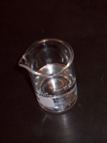
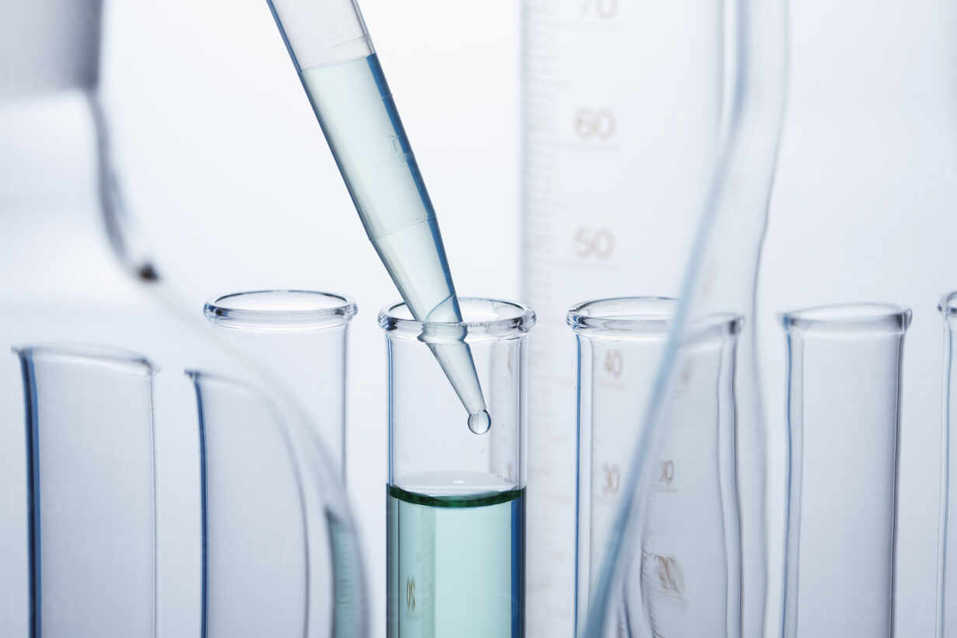
- Next, find your group’s p20 micropipette, and note the narrower shaft size which accommodates the yellow Fisherbrand tips. This size micropipette requires even more precision than the p1000.

NOTE: When dispensing (small) volumes using the p20 pipette, try to submerge the tip in the liquid/solution of your destination tube. Otherwise, the volume may stick to/form a bead on the outside of the tip. Also, push the plunger to its 2nd stop to completely expel any residual volume from your tip, then remove your tip from the container’s liquid before releasing the plunger with your thumb. Ask your instructor to demonstrate if needed.

With this (2-20 uL) micropipette and using the yellow tips, obtain the following volumes:
- 20 µL (this is the upper limit of your p20 micropipette; do not twist the volume knob past this point)
- 10.5 µL
- 2 µL (this is the lower limit of your p20 micropipette; do not twist the volume knob past this point)

Using your p20 micropipette, transfer water:
To here (tube is labeled ‘P’ for ‘Practice’)
From here…
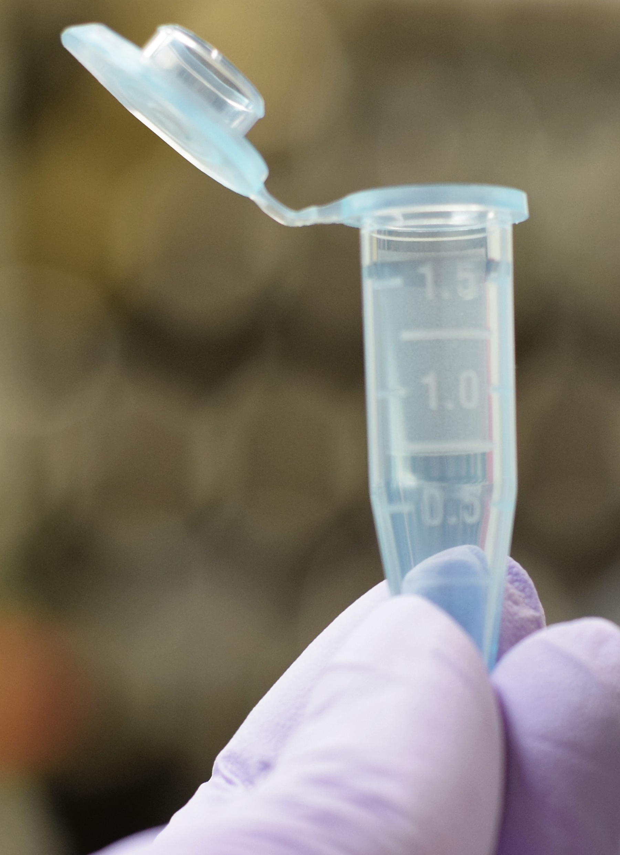

Getting comfortable with using a micropipette is critical in this course. Observe what each of the above volumes looks like in your pipette tip, and use the space below to make accurate drawings (at scale) for reference.

Drawing of 20 µl volume in tip | Drawing of 10.5 µl volume | Drawing of 2 µl volume

B) Preparing Graphs and Standard Curves

If all goes as expected, you'll have a good bit of quantitative data in this lab. And so you will need a way to display your data in graphs because graphs are an effective way of visualizing and understanding quantitative information. A graph visually displays the relationship between variables, making them easier to grasp. In a graph, you will plot an independent variable against a dependent variable. The independent variable is the controlling variable and is always plotted on the x-axis. The dependent variable is plotted on the y-axis. For example, growth rate of plant depends on soil phosphorus concentration. Phosphorus concentration would be the independent variable on the x-axis, and plant growth rate would be the dependent variable which goes on the y-axis. Always label each axis with the name of the variable and its specific units.

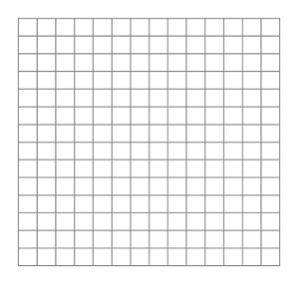
Modern spreadsheet software (such as Excel) makes graphing efficient, but there will be instances where you need to draw graphs during lab. Try graphing the following data in the space below:

Soil phosphorus (ppm) | Avg. plant height at 5 weeks (cm)
100 | 5
200 | 11
300 | 14
400 | 21
500 | 26

In general, when preparing a graph, look at the largest and smallest data values to be plotted on the X and Y –axes (axes is the plural of axis) to determine the spread of intervals on each of the axes. Begin each axis at a value slightly smaller than the smallest data value, and end the axis at a value slightly larger than the largest data value. Make the intervals on the axes such that you use the maximum amount of space on your graph paper.

NOTE: the two axes do not necessarily have the same dimensions, and a graph need not start at zero unless zero is a data point.

If plotting by hand, carefully plot each data point using a sharp pencil or ink pen. You may wish to circle each point for easier location. If you have more than one dependent variable, or if you are including data from more than one source, you can use circles, squares, triangles, etc. to distinguish their points. Draw the best smooth line that passes through the most points in each set, drawing the line so that the remaining points are somewhat equally balanced on both sides of the line. DO NOT connect the dots. If a point is very far from the other data points, ignore it.

Examine the graph to determine the relationship between the dependent and independent variables. If it seems like the data behaves linearly, draw the best straight line. If your dependent variable is directly proportional to your independent variable, the graph will produce a straight line, fitting the equation

y = mx + b

where “m” is the slope of the line (defined as the change in y/change in “x”) and “b” is the “y”-intercept (the value of “y” where the line crosses the “y”-axis). If “b” is zero, then the line passes through the origin.

For more accuracy, use regression to obtain the line of best-fit in Microsoft Excel. Regression is a statistical method that finds the line with the minimum total distance from all of the points to the line. Excel software will do this quite easily for you as well as Google Sheets. Enter the X data in a vertical column, and the Y data in a second vertical column to the right of it. (If you do it backwards the axes will be reversed.)

Select TWO cells and type in the equation or select the spreadsheet function you want to use. Excel will calculate slope and intercept with the LINEST function. In this case simply type =LINEST(C4:C8, B4:B8). C4 etc. designate cells where you entered data. Try it. You'll like it. Note all the other functions available in your software too. The LINEST function estimates a linear relationship between the variables on the two axes, however, it is important to remember that a relationship between two variables may not always be linear. In some cases the relationship may be curved or display a plateau; in these cases it is important to know that the LINEST function may not be appropriate and other functions may express the relationship between the variables more accurately (e.g., exponential, logarithmic, power, etc.).

Standard curves
We often measure the level of a variable of interest by determining its impact on some other variable. For example, a thermocouple is an electronic temperature sensor that generates a higher voltage the warmer it gets. We really measure voltage, and because we know how the system behaves, (a rise of 2 millivolts for every degree rise in temperature perhaps), we can measure voltage and convert volts to degrees. We measure chemicals because they absorb light. We convert absorbance into milligrams per ml (concentration).

In either case, once you have graphed voltage (y-axis) vs. temperature (x-axis) or absorbance (y-axis) vs. concentration (x-axis), you can use the graph as a standard curve. If you measure the voltage from the thermocouple, then look up that voltage on the y-axis of the graph; draw a horizontal line from the voltage on the y-axis to the graphed line; drop a vertical line down to the x-axis and read the temperature. You can do the same process with a spectrophotometer to use absorbance to determine concentration.

The following resources may be helpful to you:

http://www.mathsisfun.com/data/scatter-xy-plots.html

http://www.youtube.com/watch?v=LPFrV-QhQE4

Lab 1, Activity 2: Diffusion

Purpose: To explore some of the factors that affect the rate at which diffusion occurs and to create a standard curve to determine an unknown.

The Basics of Diffusion

All atoms, ions, and molecules, are in constant motion due to the kinetic energy that they possess. This continuous, random motion results in molecular collisions that send each atom, ion or molecule bouncing in a new direction. This constant random motion eventually results in an even distribution of all components throughout the system. If a substance starts out with uneven distribution as in Figure 1 above then there is a net movement from regions of greater concentration to regions of lesser concentration until a state of equilibrium is reached is diffusion.

If the difference in concentration between high and low regions is great, and the distance between the regions is small, the concentration gradient between them is said to be steep, and diffusion will proceed rapidly. Other factors also affect the diffusion rate. The rate of diffusion depends on the molecular weight of the molecule, with smaller molecules moving more rapidly and therefore diffusing more rapidly. The rate of diffusion increases with temperature, since heat increases the kinetic energy of the molecules.

Diffusion also occurs in air. Gases diffuse more rapidly than liquids because gas molecules are slowed less by interactions with each other than are molecules in water. There are no hydrogen bonds in air to slow movement.

Cells frequently create gradients across their membranes. This requires energy, generally in the form of ATP. Once the gradient has been formed, atoms and molecules can then move down the gradient due to potential energy.

Diffusion of one substance is generally independent from movement of other molecules, and gaseous exchange between living cells and their environment occurs according to this principle. As cells use oxygen during respiration, a region of low concentration develops, and oxygen diffuses into the cell. Cells produce carbon dioxide during respiration, creating a region of high concentration, and carbon dioxide diffuses out of the cell. Oxygen and carbon dioxide do not interfere with each other even though they are diffusing in opposite directions.

Diffusion of gases and diffusion of liquids over short distances (about the diameter of the cell) occur rapidly enough to provide efficient movement of materials at no cost to the cell. On the other hand, diffusion in water over large distances occurs too slowly to be of use in distributing materials. For this reason, plants and animals have specialized, energy-driven systems for long distance transport of nutrients and other molecules. Examples of these systems are xylem and phloem tubes in vascular plants and the cardiovascular system of vertebrates.
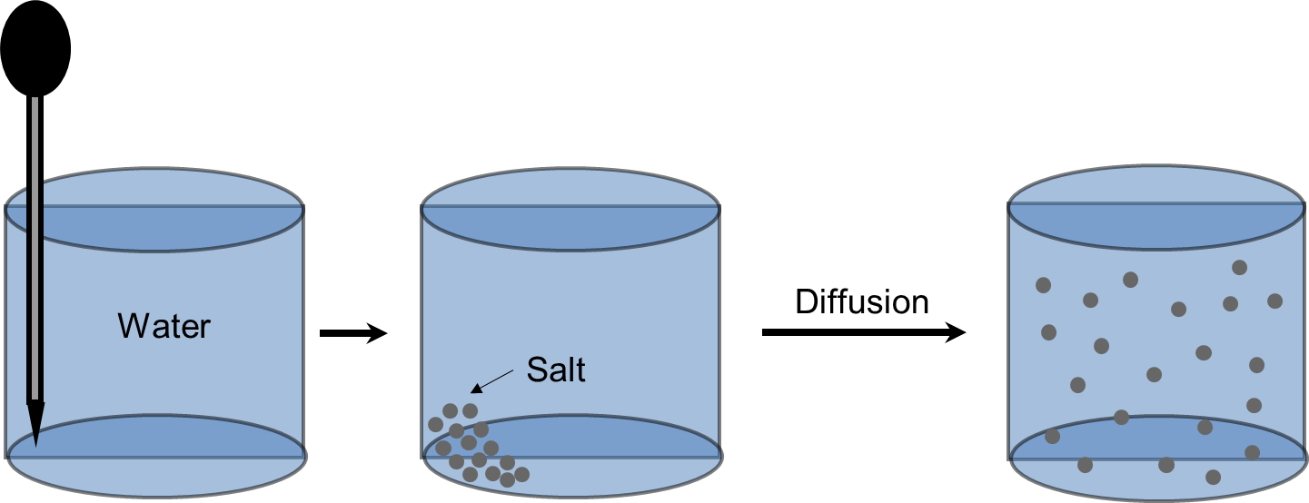

Figure 1. Diffusion of salt in water.
The Physics of Diffusion

You need to understand the physics of diffusion. It is relatively simple. First you need to understand energy. The first law of thermodynamics describes the fact that energy cannot be created nor destroyed. But it can be converted from one form to another. For instance – you hold a ball in your hand. That ball has potential energy (energy due to position) because it is a few feet away from the floor. When you let go of the ball, the potential energy is converted to kinetic energy (energy due to motion) and the ball moves to the floor (it may bounce a few times but it eventually rests on the floor). Now where is the energy? It has been lost to heat, the ultimate fate of all energy forms. How much heat? Exactly the same amount as the potential energy that the ball originally had in your hand.

So how does this apply to diffusion in today’s lab exercise? You start out with potential energy when the dye is in the agar well and there is no dye in the agar. This is energy due to position. Another way of stating this fact is to say that all concentration gradients are a form of potential energy. As the dye molecules move out into the agar, potential energy is converted to kinetic energy. Once the dye molecules have moved as far as they can in the agar, what energy is left? From the above paragraph, you should know that all of the energy is now lost as heat. And the amount of heat energy is exactly the same as the original potential energy due to the position of the dye in the agar well or hole.

The rate of diffusion increases with the concentration gradient. We can test this statement by introducing dye at different concentrations into an ¹agar plate, incubating to allow diffusion, and measuring the diameter of the resulting colored zone. We can then use the results from known concentrations of dye to determine the dye concentration of an unknown sample.

Procedure:
- Use a Sharpie to divide a water agar plate into six equally sized pieces by marking on the bottom of the plate. Label the bottom of the plate (near the edge of each sector) with each of the five final dye concentrations listed in the table below. In the sixth section, mark a "?" for the unknown sample.
- Use a plastic transfer pipet to punch a hole in the agar in the center of each section about 15 mm from the edge of the plate; this creates a “well” for you to add various dilutions of dye into. It helps to squeeze the pipet bulb before stabbing the tip of the pipet straight down to the bottom of the dish, then release the bulb to draw up the agar plug into the pipet. Ask your instructor to demonstrate, or try this on a ‘practice’ plate if needed.
____________________________________________________________________________________
¹ Agar is an algal polysaccharide (seaweed!) that forms a gel when dissolved in water. Agar is the most common solidifying agent for microbiological media. In this exercise, it forms a matrix which allows the dye to move by diffusion, but keeps the dye from being mixed when the plate is moved

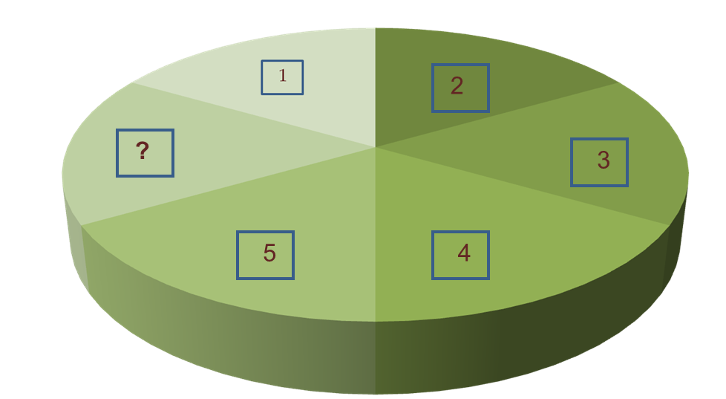
Figure 2: Plate for measuring zones of diffusion.

- Mix Amido black dye solution (5.0 mg/ml - stock solution) with distilled water in microfuge tubes to obtain four solutions with different concentrations of Amido black as shown in Table 1. Use your p1000 (100-1000 µl) micropipette for this. You don't need to use a microfuge tube for the ‘1X’ dilution (the 5 mg/ml stock bottle is already at the required concentration – you may take it directly out of the bottle when loading that well). It helps to add the needed amount of stock dye to each tube in the order shown below so that you can use the same blue tip for each transfer. When finished adding your dye, eject your tip and replace it with a clean one for each of your water transfers. After adding water to any tube, immediately use your micropipette to mix each solution by slowly/carefully pipetting up and down 3 to 4 times; take care not to do this too vigorously or you may splash liquid out of your tube.
- Separately, obtain a dye solution of unknown concentration (white capped bottle labeled “Unknown”).

Table 1-1: Diluting Amido Black
Amido black stock (µl) | Water (µl) | Dilution Factor | Final concentration Amido black (mg/ml)
200 | 800 | 0.2X | 1
400 | 600 | 0.4X | 2
600 | 400 | 0.6X | 3
800 | 200 | 0.8X | 4
1000 | 0 | 1.0X | 5

- Time to put your micropipette skills to the test! Use your p20 (2-20 µl) micropipette to fill each well with 10 µl of its corresponding solution. Be sure to use a new yellow tip for each solution. Ask your instructor if you need help.

Allow the dye to diffuse for 1 hour in the 37° C incubator so that you can detect differences between the concentrations. One person in your group may want to keep the Petri dish for further incubation at ambient temperature. Check to-see if further incubation increases the differences in diameters in a useful manner.

Clean-up: Place all used microfuge tubes and agar plates in the labeled discard bin. Leave your ‘P’ (Practice) tubes for the next lab section.

DIFFUSION
PRELAB PREPARATION:

- Define dependent and independent variable. When it comes to constructing a graph, which variable should be on the x-axis and which should go on the y-axis?

- Provide an example of when a line a graph would be the best choice of graph? When would a bar graph be a good choice of graph?

- Define diffusion and explain why diffusion occurs:

- What factors influence the rate of diffusion? What is their effect?

- List three biologically important examples of diffusion.

- Predict which dye concentration(s) will produce the largest zone of color. Defend your prediction.

- How can a graph be used to find the concentration of an unknown?

- If 1 ml of dye plus 2 ml of water gives a 0.33 dilution, what dilution is 1 ml of dye plus 3 ml of water?

RESULTS:

- Effect of dye concentration on rate of diffusion:

Final Dye Concentration | Diameter of Colored Zone (mm)
1 mg/ml
2 mg/ml
3 mg/ml
4 mg/ml
5 mg/ml
Unknown

- In the space below, graph the diameter of the colored zone against the dye concentration.

4. What is the diameter of the colored zone of your unknown? ___________

5. What is the dye concentration of your unknown? ____________

Lab 1, Activity 3: CURE project brainstorming and identifying variables

Introduction: Our last activity will help you to start thinking about your CURE research plan by introducing you to the 4 lab activities that will be performed. By doing so, you are more likely to turn in a better research plan and collect useful data during the two CURE lab periods (Weeks 5 and 6). This brainstorming exercise will also give you some practice in identifying variables.

Instructions: Below are brief overviews of the CURE activities/procedures we will perform. You will also find each CURE activity/experimental setup on display in the lab room to help you visualize the materials that will be used. Read each description and complete the following tables. Additionally, when researching/brainstorming possible ideas, try and think about a single independent variable (test substance) that would yield meaningful data for all 4 lab activities; doing so will make it easier to connect your results into a broader context from which you can draw conclusions (this is not required, but highly recommended). Please refer to Labs 5 and 6 (in this manual) for procedural details as needed.

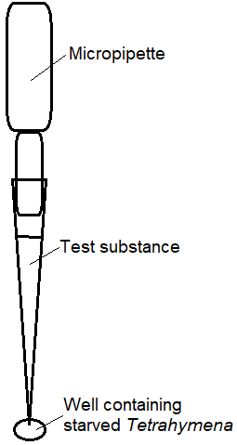
CURE Activity #1: Chemotaxis (Week 5)
Figure 3. Chemotaxis assay diagram.
Tetrahymena eats particles in the water (namely, bacteria and tiny pieces of dead/decaying organisms) while also avoiding predators and other threats. Like other organisms, it needs to be able to locate food and avoid dangers in order to survive. Because it lacks sensory organs like eyes, ears or a nose, it must sense and respond to chemicals dissolved in its environment using chemotaxis – an organism’s ability to change direction in response to chemicals in its environment. Tetrahymena tends to swim towards chemoattractants and away from chemorepellants.

Synopsis of Chemotaxis assay: Your group will suspend various liquid substances (including proteose peptone, a nutrient media used as a positive control) in a micropipette tip, and submerge this tip in a small well containing starved Tetrahymena for a fixed amount of time. Once time is up, you will count/quantify any cells that moved from the well into the tip (containing either your positive control or a test substance). Any movement of Tetrahymena into the micropipette tip indicates the substance is a chemoattractant; if no Tetrahymena move into the well, then it’s possible that the substance is acting as a chemorepellant.

Now complete the following table; refer to Lab 5 (Chemotaxis) in this manual as needed. Individually, jot down some possible ideas for independent variables (i.e., substances or solutions) that could affect chemotaxis in Tetrahymena (that you could test in lab). Briefly describe why you think testing the substance would be interesting and/or relevant/important (look ahead to the other 3 activities as well – ideally, you want to be able to ‘tell a story’ with your data/results). To begin, consider the basic chemical properties of a common household substance (e.g. pH, key ingredients, any information on the toxicity/environmental effects of key ingredients/how biodegradable they are, etc.) - this may require a quick internet search. Then, discuss/evaluate your ideas for test substances with your lab group and select the one that seems the most promising. Listen to everyone’s ideas; as you listen, jot them down under ‘Group brainstorming’.

Chemotaxis Activity
Dependent variable
Controlled variable(s)
Individual brainstorming (ideas for independent variable(s) and rationale for testing them) |  | Group brainstorming (ideas for independent variable(s) and rationale for testing them )
Group hypothesis:
Prediction (what you expect to occur after adding your variable):

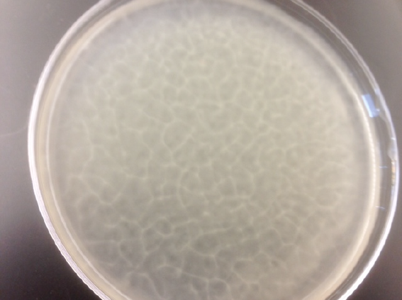
CURE Activity #2: Bioconvection/Pattern Formation (Week 5)
Figure 4. Tetrahymena pattern in an undisturbed petri dish.
Tetrahymena spontaneously form a honeycomb-like pattern when left undisturbed in lab containers, as long as a minimum volume depth (2mm) and culture concentration (~1.5x10⁵ cells/mL) is present; this was first described by Loefer and Medferd in 1952. This pattern disappears momentarily when the container is swirled, but reappears after the medium settles back down. Pattern formation times can vary based on environmental factors. Researchers believe the pattern forms in part due to “negative gravitaxis”, which means that Tetrahymena generally tend to move upward, against the force of gravity. When there is a high enough concentration of Tetrahymena in a given volume, they tend to form random clumps at the top as they all swim upwards. The density of these clumps of cells becomes too great for the upward exertions of the Tetrahymena to overcome. As a result, they fall downward in columns, creating the pattern shown in Fig. 4. Scientists came to this conclusion after experiments revealed that Tetrahymena patterns disappeared in a zero-gravity environment and became more pronounced in a hypergravity (increased gravity) environment. This process of up-swimming and down-falling (and resulting pattern formation) is called bioconvection. Your goal in this activity will be to investigate factors (independent variables) that might affect bioconvection (pattern formation) in Tetrahymena. Your primary dependent variable in this lab will be pattern formation time; additionally, you can also observe how well-defined/sharp the pattern is. As with the previous page, please complete the following table. Possible ideas for independent variables to test include various nutrient medias (limited to Dept. availability), depth of the culture volume, temperature, light conditions, pH, magnets, or other objects in the environment. However, it is up to you/your group to research their potential significance. It may be more prudent to test the same independent variable (test substance) that your group chose for the Chemotaxis lab.

Bioconvection/Pattern Formation Activity
Dependent variable
Controlled variable(s)
Individual brainstorming (ideas for independent variable(s) and rationale for testing them, including possible connections to Chemotaxis) |  | Group brainstorming (ideas for independent variable(s) and rationale for testing them, including possible connections to Chemotaxis)
Group hypothesis:
Prediction (what you expect to occur after adding your variable):

CURE Activities #3 and #4: Phagocytosis and Osmosis (Week 6)

Phagocytosis: To obtain food, Tetrahymena sweep bacteria and/or other tiny particles from their aquatic environment into their buccal cavity (mouth). These particles are eventually deposited in food vacuoles (unique from contractile vacuoles) inside the cell.
Synopsis of Phagocytosis experiment: For this lab activity, your group will run an experiment to test a factor that might affect food vacuole formation (again, this will most likely be the ‘test substance’ you used in the previous activities unless you have a good reason for manipulating another variable). To visualize vacuole formation, you will introduce India ink (1% working concentration) into the cells’ environment. Within 20 minutes of treatment, you should see the formation of food vacuoles, which will appear as black spheres in the Tetrahymena. Your experiment will test a single independent variable while also including a control sample (standard condition) and compare the number of food vacuoles that form in cells between the two treatments.
Osmosis: As you’ll explore in Lab 6, osmosis is the movement of solvent/water molecules through a selectively permeable membrane from a region of lower solute concentration to a region of higher solute concentration. Maintaining an isotonic environment with the external environment is critical for living cells to survive. Protists, like Tetrahymena, actively pump water out of the cell using a specialized organelle called a contractile vacuole.
Synopsis of Osmosis experiment: Your group will place Tetrahymena in solutions that are hypotonic, isotonic and hypertonic to their cells and observe/measure how these solutions affect the rate of vacuole contraction in the organism. You will also measure the osmotic effects of your group’s test substance (the same substance from your Chemotaxis experiment). As mentioned before, it is recommended that you further explore the test substance you chose for some (or all) of the previous experiments.

Phagocytosis and Osmosis Activities
Dependent variable
Controlled variable(s)
Individual brainstorming (ideas for independent variable(s) and rationale for testing them, including possible connections to Chemotaxis or Pattern Formation) |  | Group brainstorming (ideas for independent variable(s) and rationale for testing them, including possible connections to Chemotaxis or Pattern Formation)
Group hypothesis:
Prediction (what you expect to occur after adding your variable):

POST-LAB QUESTIONS:

- Determine the equation of the line on your graph. What does this equation tell you? What concentration of dye would give a zone of 25 mm?

- What would happen to the dye on the agar plate if you waited too long to measure the diameters of the colored zones? Explain your reasoning.

- Did your results agree with your predictions? Explain any unexpected results.

- Describe any sources of error in your experiments.

Attributions:
Designing an Experiment is licensed CCBY-4.0/a derivative of original work from "Psychology 2e" by OpenStax.
Lab 2- Introduction to Tetrahymena and Microscopy

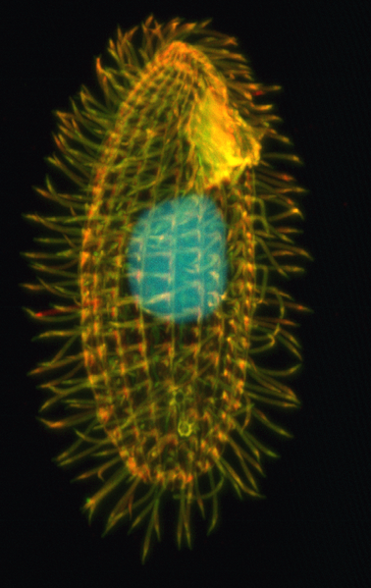
Introduction
Figure 2. Micrograph of Tetrahymena thermophila. https://commons.wikimedia.org/wiki/File:Tetrahymena_thermophila.png
This semester, you will work with the model system Tetrahymena thermophila (Fig. 1) in several labs to answer a research question chosen by you and your lab partners. Tetrahymena is an example of a model organism. A model organism is one that is well understood, allowing scientists to perform manipulations to them or their environment to answer complex and fundamental questions. Tetrahymena are unicellular organisms that are too small to be observed with the naked eye. In today’s lab, we will first focus on learning microscope techniques and then we will apply your new skills to observing Tetrahymena. Microscopes are expensive scientific equipment and should always be treated with care and respect. The skills you will learn in this lab are fundamental to the success of your C.U.R.E project, so practice/get comfortable using a microscope and ask your instructor for help as needed.

Microscopy

Although cells vary in size, they’re generally quite small. For instance, the diameter of a typical human red blood cell is about eight micrometers (0.008 millimeters). To give you some context, the head of a pin is about one millimeter in diameter, so about 125 red blood cells could be lined up in a row across the head of a pin. With a few exceptions, individual cells cannot be seen with the naked eye, so scientists must instead use microscopes to study them. A microscope is an instrument that magnifies objects otherwise too small to be seen, producing an image in which the object appears larger. Most photographs of cells are taken using a microscope, and these pictures can also be called micrographs.
From the definition above, it might sound like a microscope is just a kind of magnifying glass. In fact, magnifying glasses do qualify as microscopes; since they have just one lens, they are called simple microscopes. The fancier instruments that we typically think of as microscopes are compound microscopes, meaning that they have multiple lenses. Because of the way these lenses are arranged, they can bend light to produce a much more magnified image than that of a magnifying glass.
What separates a simple microscope from the powerful equipment used in a research lab? Three parameters are especially important in microscopy: magnification, resolution and contrast.
- Magnification is a measure of how much larger a microscope (or set of lenses within a microscope) causes an object to appear. For instance, the light microscopes typically used in high schools and colleges magnify up to about 400 times actual size. So, something that was 1 mm wide in real life would be 400 mm wide in the microscope image.
- The resolution of a microscope or lens is the smallest distance by which two points can be separated and still be distinguished as separate objects. The smaller this value, the higher the resolving power of the microscope and the better the clarity and detail of the image. If two bacterial cells were very close together on a slide, they might look like a single, blurry dot on a microscope with low resolving power, but could be told apart as separate on a microscope with high resolving power.
- Modern microscope technology can produce images with very high magnification and resolution, however such equipment is worthless without adequate contrast. Contrast is the ability to distinguish the specimen from its background. The lighter/more transparent a specimen is, the easier it is to see on a darker background. Colorless or very transparent specimens may require a phase contrast microscope and/or the application of stains to be clearly seen.

Magnification, resolution and contrast are equally important if you want a clear picture of something very tiny. For example, if a microscope has high magnification but low resolution, you will just see a bigger version of a blurry image. Similarly, a microscope with sufficient resolution but poor contrast would not be useful for observing most specimens. Different types of microscopes differ in their magnification, resolution and contrast, and there are sometimes tradeoffs between these 3 factors among different microscope technologies.

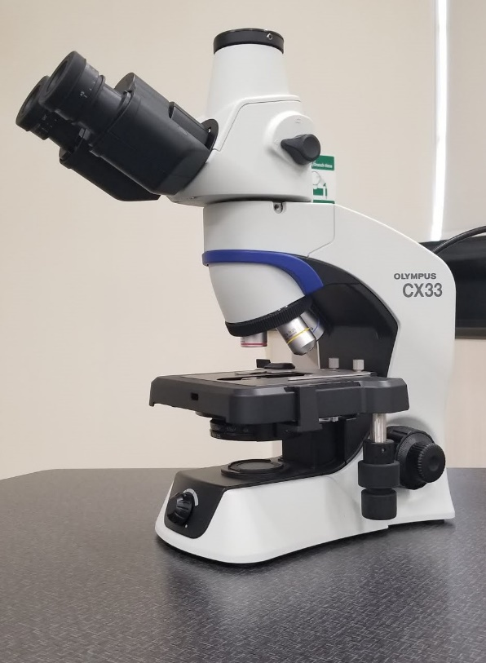
Light microscopes

The microscopes in the Biol 1A lab are classified as light microscopes (Fig 2). In a light microscope, visible light passes through the specimen (the biological sample you are looking at) and is bent through the lens system, allowing the user to see a magnified image. A benefit of light microscopy is that it can often be performed on living cells, so it’s possible to watch cells carrying out their normal behaviors (e.g., migrating or dividing) under the microscope.
The Biol 1A microscopes are brightfield microscopes, meaning that visible light is passed through the sample and used to form an image directly, without any modifications. Slightly more sophisticated forms of light microscopy use optical tricks to enhance contrast, making details of cells and tissues easier to see.
Another type of light microscopy is fluorescence microscopy, which is used to image samples that fluoresce (absorb one wavelength of light and emit another). Light of one wavelength is used to excite the fluorescent molecules, and the light of a different wavelength that they emit is collected and used to form a picture. In most cases, the part of a cell or tissue that we want to look at isn't naturally fluorescent, and instead must be labeled with a fluorescent dye or tag before it goes on the microscope.
Figure 3. The compound light microscope used in Biol 1A.
Even more detailed images can be obtained using a specialized kind of fluorescence microscopy called confocal microscopy. A confocal microscope uses a laser to excite a thin layer of the sample and collects only the emitted light coming from the target layer, producing a sharp image without interference from fluorescent molecules in the surrounding layers.

Electron Microscopes

Some types of light microscopy (beyond the techniques we discussed above) can produce very high-resolution images. However, if you want to see something very tiny at very high resolution, you may want to use a different, tried-and-true technique: electron microscopy.
Electron microscopes differ from light microscopes in that they produce an image of a specimen by using a beam of electrons rather than a beam of light. Electrons have much a shorter wavelength than visible light, and this allows electron microscopes to produce higher-resolution images than standard light microscopes. Electron microscopes can be used to examine not just whole cells, but also the subcellular structures and compartments within them.
One limitation, however, is that electron microscopy samples must be placed under a vacuum in electron microscopy (and are typically prepared via an extensive fixation process). This means that live cells cannot be imaged.
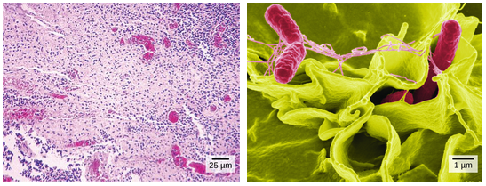
Figure 4. Images of Salmonella bacteria taken via light microscopy (left) and scanning electron microscopy (right). Much more detail can be seen in the scanning electron micrograph.
There are two major types of electron microscopy. In scanning electron microscopy (SEM), a beam of electrons moves back and forth across the surface of a cell or tissue, creating a detailed image of the 3D surface. Figure 3 compares how Salmonella bacteria look in a light micrograph (left) versus an image taken with a scanning electron microscope (right). The bacteria show up as tiny dots in the light microscope image, whereas in the electron micrograph, you can clearly see their shape and surface texture, as well as details of the human cells they’re trying to invade.

In transmission electron microscopy (TEM), in contrast, the sample is cut into extremely thin slices (for instance, using a diamond cutting edge) before imaging, and the electron beam passes through the slice rather than skimming over its surface. TEM is often used to obtain detailed images of the internal structures of cells. Electron microscopes are significantly bulkier and more expensive than standard light microscopes, perhaps not surprisingly given the subatomic particles they have to handle!

Scanning Probe Microscopy
A relatively recent microscope technology called scanning probe microscopy (SPM) includes two main types: atomic force microscopy (AFM) and scanning tunneling microscopy (STM). In AFM, a nanometer-sized probe (the tip of which ranges from 1-10 nm) gently touches the surface of a sample, which generates a three-dimensional image as either the tip moves across the sample or the sample is moved across a stationary tip. Because it is within atomic distance of the surface, an AFM probe can sense the repulsive and attractive forces from the surface and allow for resolution on the order of fractions of a nanometer. This is more than 1,000 times greater than the optical diffraction limit of light microscopes (~250 nm). While STM uses similar nanoscale probes, its images are generated indirectly by calculating the quantum degree tunneling (tunneling current) between the probe and sample. In this case, the probe never makes direct contact with the sample surface.
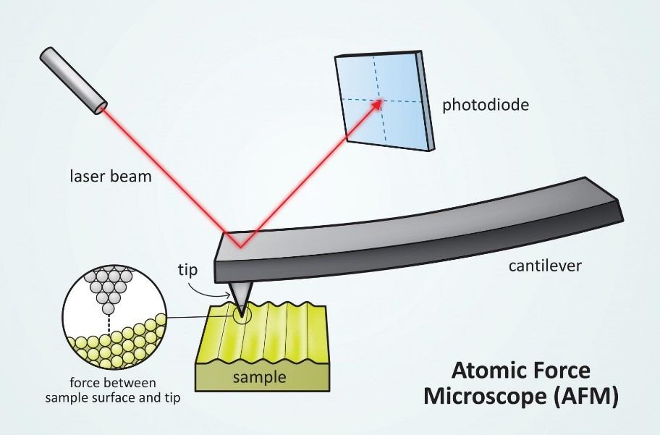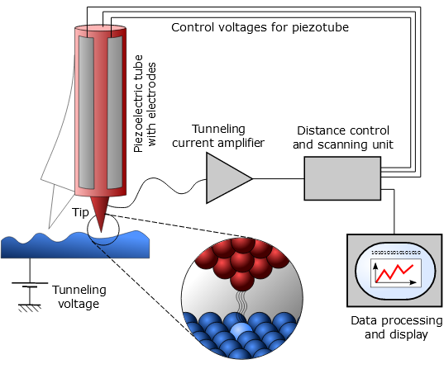
Figure 4. Conceptual images of atomic force microscopy (AFM), left and scanning tunneling microscopy (STM), right.

Microscope Use and Care

Microscopes are expensive, fragile instruments; therefore, you should always handle them with care. Follow these guidelines whenever using a microscope:

- Always use both hands to pick up a microscope; pick them up by either placing both hands around the “arm” of the scope (curved area supporting the objective lens and eyepiece) OR with one hand on the arm and the other underneath the base. Watch your step while carrying.
- Gently push the thumb lever on the stage clip whenever inserting/removing slides.
- You should never turn the coarse adjustment knob when using the 10x or 40x objectives.
- Only use lens paper to clean microscope lens; wipe once using a straight, sweeping motion.
- When finished using the microscope, lower the stage completely, return the 4x objective into place, remove any slides from the stage, bundle up the power cord/place in the holder behind the scope, replace the scope cover and return it to the shelf with the eyepiece facing inward. Your lab instructor will deduct lab participation points if these directions are not followed.

Lab 2, Part 1: Microscopy fundamentals and eukaryotic cell observation

When carrying the microscopes in lab, always use two hands, one on the base and one on the neck. The microscope consists of a stand (base + neck), on which is mounted the stage (for holding microscope slides) and lenses. The lens that you look through is the ocular lens and the lens that focuses on the specimen is the objective lens. Your microscope has three objectives of varying magnifications (4x, 10x and 40x) mounted on a revolving nosepiece. Positioning the specimen requires that you turn the stage controls, which operate the slide bracket on the surface of the stage. One control moves the specimen in the x-direction, and the other moves the specimen in the y-direction. Focusing on the specimen is achieved by knobs that move the stage up and down, so that it is closer or farther from the objective. There are two knobs, an outer coarse focus and an inner fine focus. The condenser directs light through the slide into the objective. An iris diaphragm on the condenser controls the amount of light reaching the objective, and also affects the contrast of the specimen. Prior to Lab 2, watch the video posted on Canvas and label the microscope figure in the pre-lab section.

Exercise 1.1: Magnification

The compound microscope has two sets of lenses; the ocular lens (or eyepiece) which magnifies an object 10 times its normal size, and the objective lenses located on a revolving nosepiece. Rotate the nosepiece and notice how each objective lens clicks into place. The red objective is the 4x objective, which is also known as the scanning objective. Every time you use the microscope you will begin with the scanning objective. The yellow objective is the 10x objective, or the low power objective and the blue objective is the 40x or high power objective.
When viewing a specimen though the microscope, the image is being magnified by both the ocular and objective lenses. To calculate the total magnification of the image, multiply the ocular power times the objective lens that is in place. For example, if you have a 10x ocular and a 10x objective, the total magnification is: 10x * 10x = 100x. Use this information to fill in the table below.

Table 1. Total Magnification Calculations

 | Power of Objective | Power of Ocular | Total Magnification
Scanning Power
Low Power
High Power
Oil Immersion

Exercise 1.2: Focusing the Microscope and Inversion Phenomenon

Obtain a letter “e” slide. View the slide with your eyes, and then follow the directions below to focus the microscope and view it under the scanning, low and high objective.
- Make sure the microscope is in the “starting position”. The stage should be completely lowered and the scanning objective in place.
- Place your slide on the stage, using the stage clamp to secure it. The stage clamp moves only within the horizontal plane of the stage, and it secures the slide by just barely touching the bottom right corner of the slide.
- Center the specimen on your slide under the objective by moving the stage.
- Look through the oculars and use the coarse focus knob to move the stage upward until your specimen comes into focus, then sharpen the focus using the same knob.
- Draw what you see at scanning power in Table 2.
- Note the position of the letter “e” on the slide (using your eyes only). Compare this to what you see through the eyepiece. Hint: are they both right side up?
- Center the specimen in your field of view by moving the stage and slowly rotate the low power (10X) objective into position.
- Sharpen the focus, if necessary, with the fine focus knob. Only a minimal amount of adjustment is usually necessary. Do not use the coarse focus.
- Draw what you see at low power in Table 2.
- Move your slide to the right using the mechanical stage lever while looking through the oculars. Which way does the “e” move?

- Move your slide away from you using the mechanical stage lever while looking through the oculars. Which way does the “e” move?

- Rotate the high power objective into place very carefully!
- Look through the oculars and using the fine focus knob only, sharpen focus. Re-center if necessary. (If your specimen has “disappeared”, immediately return to low power and re-center the specimen.)
- Draw what you see at high power in Table 2.
- When removing a slide, always return the objectives to the scan position and lower the stage before lifting the slide off!

Table 2. Letter “e” slide
Scanning Power (4x lens) | Low Power (10x lens) | High Power (40x lens)

Exercise 1.3: Field of view
The field of view is the amount of the specimen you see when you look through the objectives. The field of view decreases at higher magnifications.
- Place a thin, clear, plastic ruler across the stage and focus on the ruler under the scanning objective.
- Move the stage so that one line of the ruler lines up with the left side of your field of view. Each line/increment represents 1 millimeter.
- Estimate the field size in millimeters for the scanning objective lenses and record in Table 3.
- Repeat with the low and high power objectives.

Table 3. Field of view
 | Scanning Power | Low Power | High Power
Field of view (mm)
Field of view (µm)

Exercise 1.4: Depth of field

Depth of field refers to the thickness of the plane of focus. With a large depth of field, a thicker sample can be in focus at the same time. With a narrower depth of field, a thinner portion of the specimen can be focused at a time. To observe the depth of field, we will use a slide of three colored threads that cross in the middle.

  - Obtain a slide of colored threads and view them under scanning power. Focus on the center of the slides, where all three threads cross.
  - Can you tell which thread is on top and which is on the bottom? Can all threads be in focus at the same time, or just one of them?

  - View the threads under high power. As you rotate the fine focus, different strands will go out of focus while others will become more sharply focused.
  - Are all of the threads in focus at the same time on high power?

  - What is the order of threads (from top to bottom)?

Exercise 1.5: Observing Plant Cells

A wet mount is a common method to prepare a specimen for observations under the microscope. Your TA will demonstrate proper technique for creating a wet mount. To practice making wet mounts, we will use an aquatic plant called Elodea. Under the compound microscope you will be able to observe the cell wall and chloroplast of the plant cell. Plant cells have rigid cell walls that mark the boundary of each cell. The chloroplasts perform photosynthesis in leaf cells and will appear as a vibrant green color. There will be several chloroplasts in each cell.

Prepare a wet mount of Elodea
- Place one drop of water on a clean microscope slide.
- Using forceps, remove one leaf from the Elodea plant and lay it in the drop of water. Make sure that your leaf is flat.
- Place a coverslip on top of the Elodea leaf. To minimize air bubbles, place one side of the cover slip against the slide and slowly lower the opposite side of the coverslip.
- Wick away excess water with a Kimwipe or paper towel.

Observe the Plant Cells

- Using scanning power, locate the Elodea leaf under the microscope. Can you see cells at this magnification? Can you see any organelles? Draw your observations in Table 4, left box.

- Observe the Elodea leaf under high power. Draw your observations in Table 4, right box. What organelles can you see? Label the organelles in your drawing.

Table 4. Elodea Slides
Scanning Power (4x lens) | High Power (40x lens)

Exercise 1.6: Observing Animal Cells
Plant cells are easy to see because of the bright green color of the chloroplasts; most cells/organelles are more difficult to see because they are transparent. There are several techniques to improve the contrast of cells, one of which is staining. In this exercise, we will observe human cheek cells that are stained with Methylene blue. Methylene blue binds to DNA so the nucleus will appear blue.

Observing human cheek cells:
- Take a prepared ‘oral smear’ slide. Using the scanning (4x) objective, locate some epithelial cells under the microscope. Remember to only use the coarse focus knob at 4x. Draw what you see in Table 5, left box.
- Observe the cells under low power (10x objective); adjust your image using the fine focus knob.
- Observe the cells under high power (40x objective), making small changes to fine focus as needed. Draw your observations in Table 5, right box. What organelles can you see? Label the organelles in your drawing.
Table 5. Animal Cells
Scanning Power (4x lens) | High Power (40x lens)

Lab 2, Part 2: Microscopy with Tetrahymena thermophila

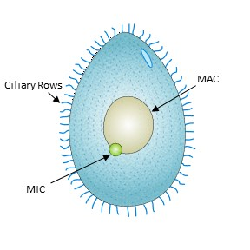
Tetrahymena thermophila is a unicellular eukaryote that lives in freshwater environments. They move through the water using cilia that protrude from their cell membrane (Fig. 4) and feed off bacteria in their environment through a process called phagocytosis. Interestingly, Tetrahymena are nuclear dimorphic, meaning they contain two nuclei. The Micronucleus (MIC) contains two sets of five chromosomes and functions in sexual reproduction. The Macronucleus has about 200 chromosomes and coordinates all the somatic (body) functions of the cell. As you can see in Figure 4, the MIC is much smaller than the MAC and is usually inactive. This separation of germline and somatic functions is similar to the germline and somatic roles found in many multicellular eukaryotes.
In addition to the features described above, the single cell of Tetrahymena has many more specialized organelles, including some we will investigate in later labs. Their cells also demonstrate most of the basic functions found in more complex eukaryotic organisms, such as humans, making it a convenient model organism for cell biology. Research on Tetrahymena has answered many fundamental questions about cell biology and has led to Nobel Prizes for the discovery of catalytic RNAs in 1982 and of telomerase and telomeres in 1985. Tetrahymena is inexpensive, easy to maintain in the lab and grows rapidly, making them an excellent model for biological research. In this activity, we will practice observing Tetrahymena under the microscope so that you are more comfortable with manipulating them during the C.U.R.E. activities.
Figure 5. Diagram of Tetrahymena Thermophila. Modified from this orignal image licensed under CCBY-4.0.

Exercise 2.1: Observing Tetrahymena thermophila

You will work with Tetrahymena several times throughout the semester; this exercise will help you practice finding and focusing on Tetrahymena cells.

- Using a micropipette, transfer a small volume of cells (e.g. 10 µL) to a glass slide. Note: you can fit at least 2 or 3 samples/cover slips on a single slide. Your instructor should demonstrate this.
- Carefully place the cover slip over your liquid sample on the slide.
- Place your slide on the microscope stage and focus under the scanning (4x) power. Unlike the Elodea and your cheek cells, the Tetrahymena will be swimming around in the liquid.
- Observe them on scanning power (4x lens). In the space below, make some notes of your observations (e.g. describe their behavior/movement patterns).
- Find a slow moving Tetrahymena and center it in the field of view. Switch to the low power (10x lens) objective and use the fine focus knob to focus your image.
- Switch to high power (40x lens) and adjust the fine focus as needed to observe the Tetrahymena. In the space below, make some notes of your observations.
- When you have completed your observations, carefully remove your slide and use it to make a second wet mount next to the first.
- Using a micropipette, transfer a small volume of cells (e.g. 10 µL) to a glass slide.
- Add 10 µL of Detain to your droplet of cells, and mix together/stir using the same pipette tip. Detain (also known as ProtoSlo/methyl cellulose) is a viscous solution that will slow down the swimming speed of the Tetrahymena and allow you to observe them more closely.
- Add a cover slip.
- Observe the cells under scanning power and low power. The Detain should slow their movement enough so that you can get a better look at a single cell.
- Observe them at high power. Can you see any organelles inside the cell? Draw what you observe in Table 6. Use as much detail as possible in your drawing and label any organelles that are visible.
- Optional: If time permits, your lab instructor can show you how to use the microscope cameras to take a high-quality image of Tetrahymena to use in your final C.U.R.E Lab Report.

Table 6. Tetrahymena Drawing

High Power – Tetrahymena thermophila

CLEANUP: Return all prepared slides (“e” and cross threads) to the appropriate trays. Discard all Elodea wet mounts and used Tetrahymena slides in the labeled plastic bin. Dispose of all cheek cell slides in the red biohazard/sharps container. Save all tubes and solutions (Detain and Tetrahymena cultures) for the next lab section. Dispose of gloves in regular trash bins. Return your microscopes to the cabinets (lower the stage completely, return the 4x objective into place, remove any slides from the stage, bundle up the power cord/place in the holder behind the scope, replace the scope cover and return it to the shelf with the eyepiece facing inward). Be sure that your group’s tray is neat and organized for the next lab section before leaving.

Exercise 2.2: Create a draft ‘Research Plan’ for the C.U.R.E. report with your group (plans are due next week!)

Last week, your group brainstormed ideas for the C.U.R.E. project/lab report (refer to your notes and ideas from Lab 1, Activity 1). Please spend the remaining time in lab researching and refining your idea(s) and/or developing an outline for your research plan with your lab group (refer to the ‘C.U.R.E. Research Plan Guidelines’ document to make sure you include all sections/requirements). Your group will be submitting ONE research plan (due next week, at the start of lab) that you will all follow in Weeks 5 and 6 (the C.U.R.E. lab activity weeks). At a minimum, you should exchange contact info with your lab group and delegate tasks (decide who will handle specific parts of the plan, who will conduct a literature search in various areas, who will submit the plan, etc.) BEFORE leaving today. Everyone should equally contribute! If there is a particularly difficult section, e.g., writing a draft protocol for the ‘Pattern Formation’ activity or deciding on which independent variables to test/determining their significance, you may want to start working on those aspects as a group, while you are all in lab together and your lab instructor is available. Your instructor will review your group’s submitted plan and return it (with feedback) in Week 4.

Use this page to draft an outline, jot down ideas/descriptions and/or delegate tasks. Please share your group’s work with your instructor before leaving today to make sure your hypotheses are testable and to clarify/anticipate any needs for the C.U.R.E. lab weeks.

Pre-Lab Questions

- Fill in the table below, describing the function of each microscope part.

Microscope Part | Function
Ocular Lens (Eyepiece)
Stage
Objective Lenses
Stage Control Knob
Fine Focus
Coarse Focus
Condenser
Iris Diaphragm
Light Source
Light Control Knob

- Label the parts listed in the table on the image below.

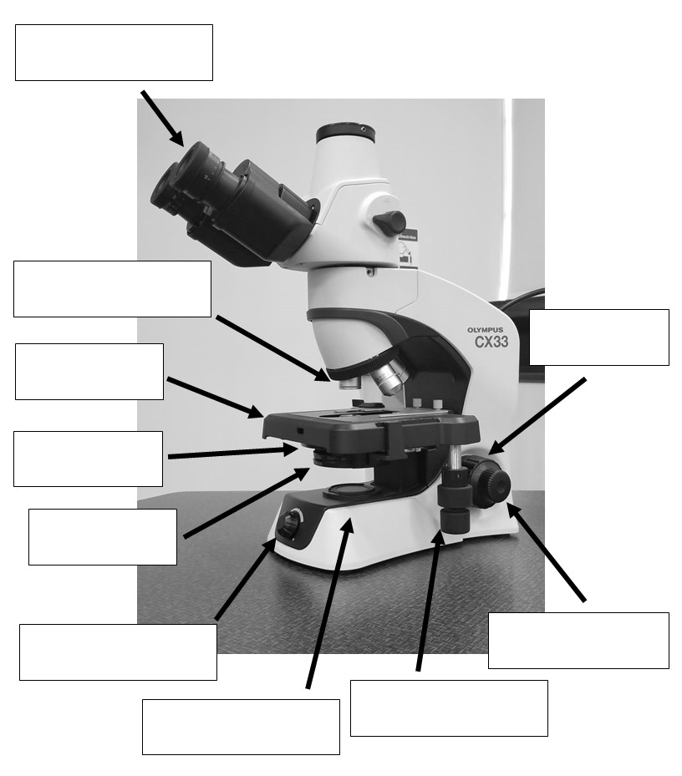

- Define magnification and resolution.

- Describe the main differences between a light microscope and an electron microscope.

- Describe the starting position for the compound microscopes in the Biol 1A lab.

- What is a model organism?

- What type of organism is Tetrahymena thermophila? Where might you find them in nature?

Post-Lab Questions

- What happens to the field of view when you switch to a higher magnification (increases, decreases, or remains the same)?

- What happens to the depth of field when you increase to a higher magnification (increases, decreases, or remains the same)?

- Why do we need to stain the cheek cells before observing them?

- What organelles were visible in the plant cells? In the animal cells?

Attributions:
Microscopy Introduction is modified from “Microscopy” by Khan Academy, licensed under CCBY-NC-SA 4.0.
Part 1: Exercises 1-5 are modified from “Microscopy and Cells” by College of the Redwoods, licensed under CC-BY 4.0.
“Lab 2: Introduction to Tetrahymena and Microscopy” is licensed under CCBY-NC-SA 4.0.

